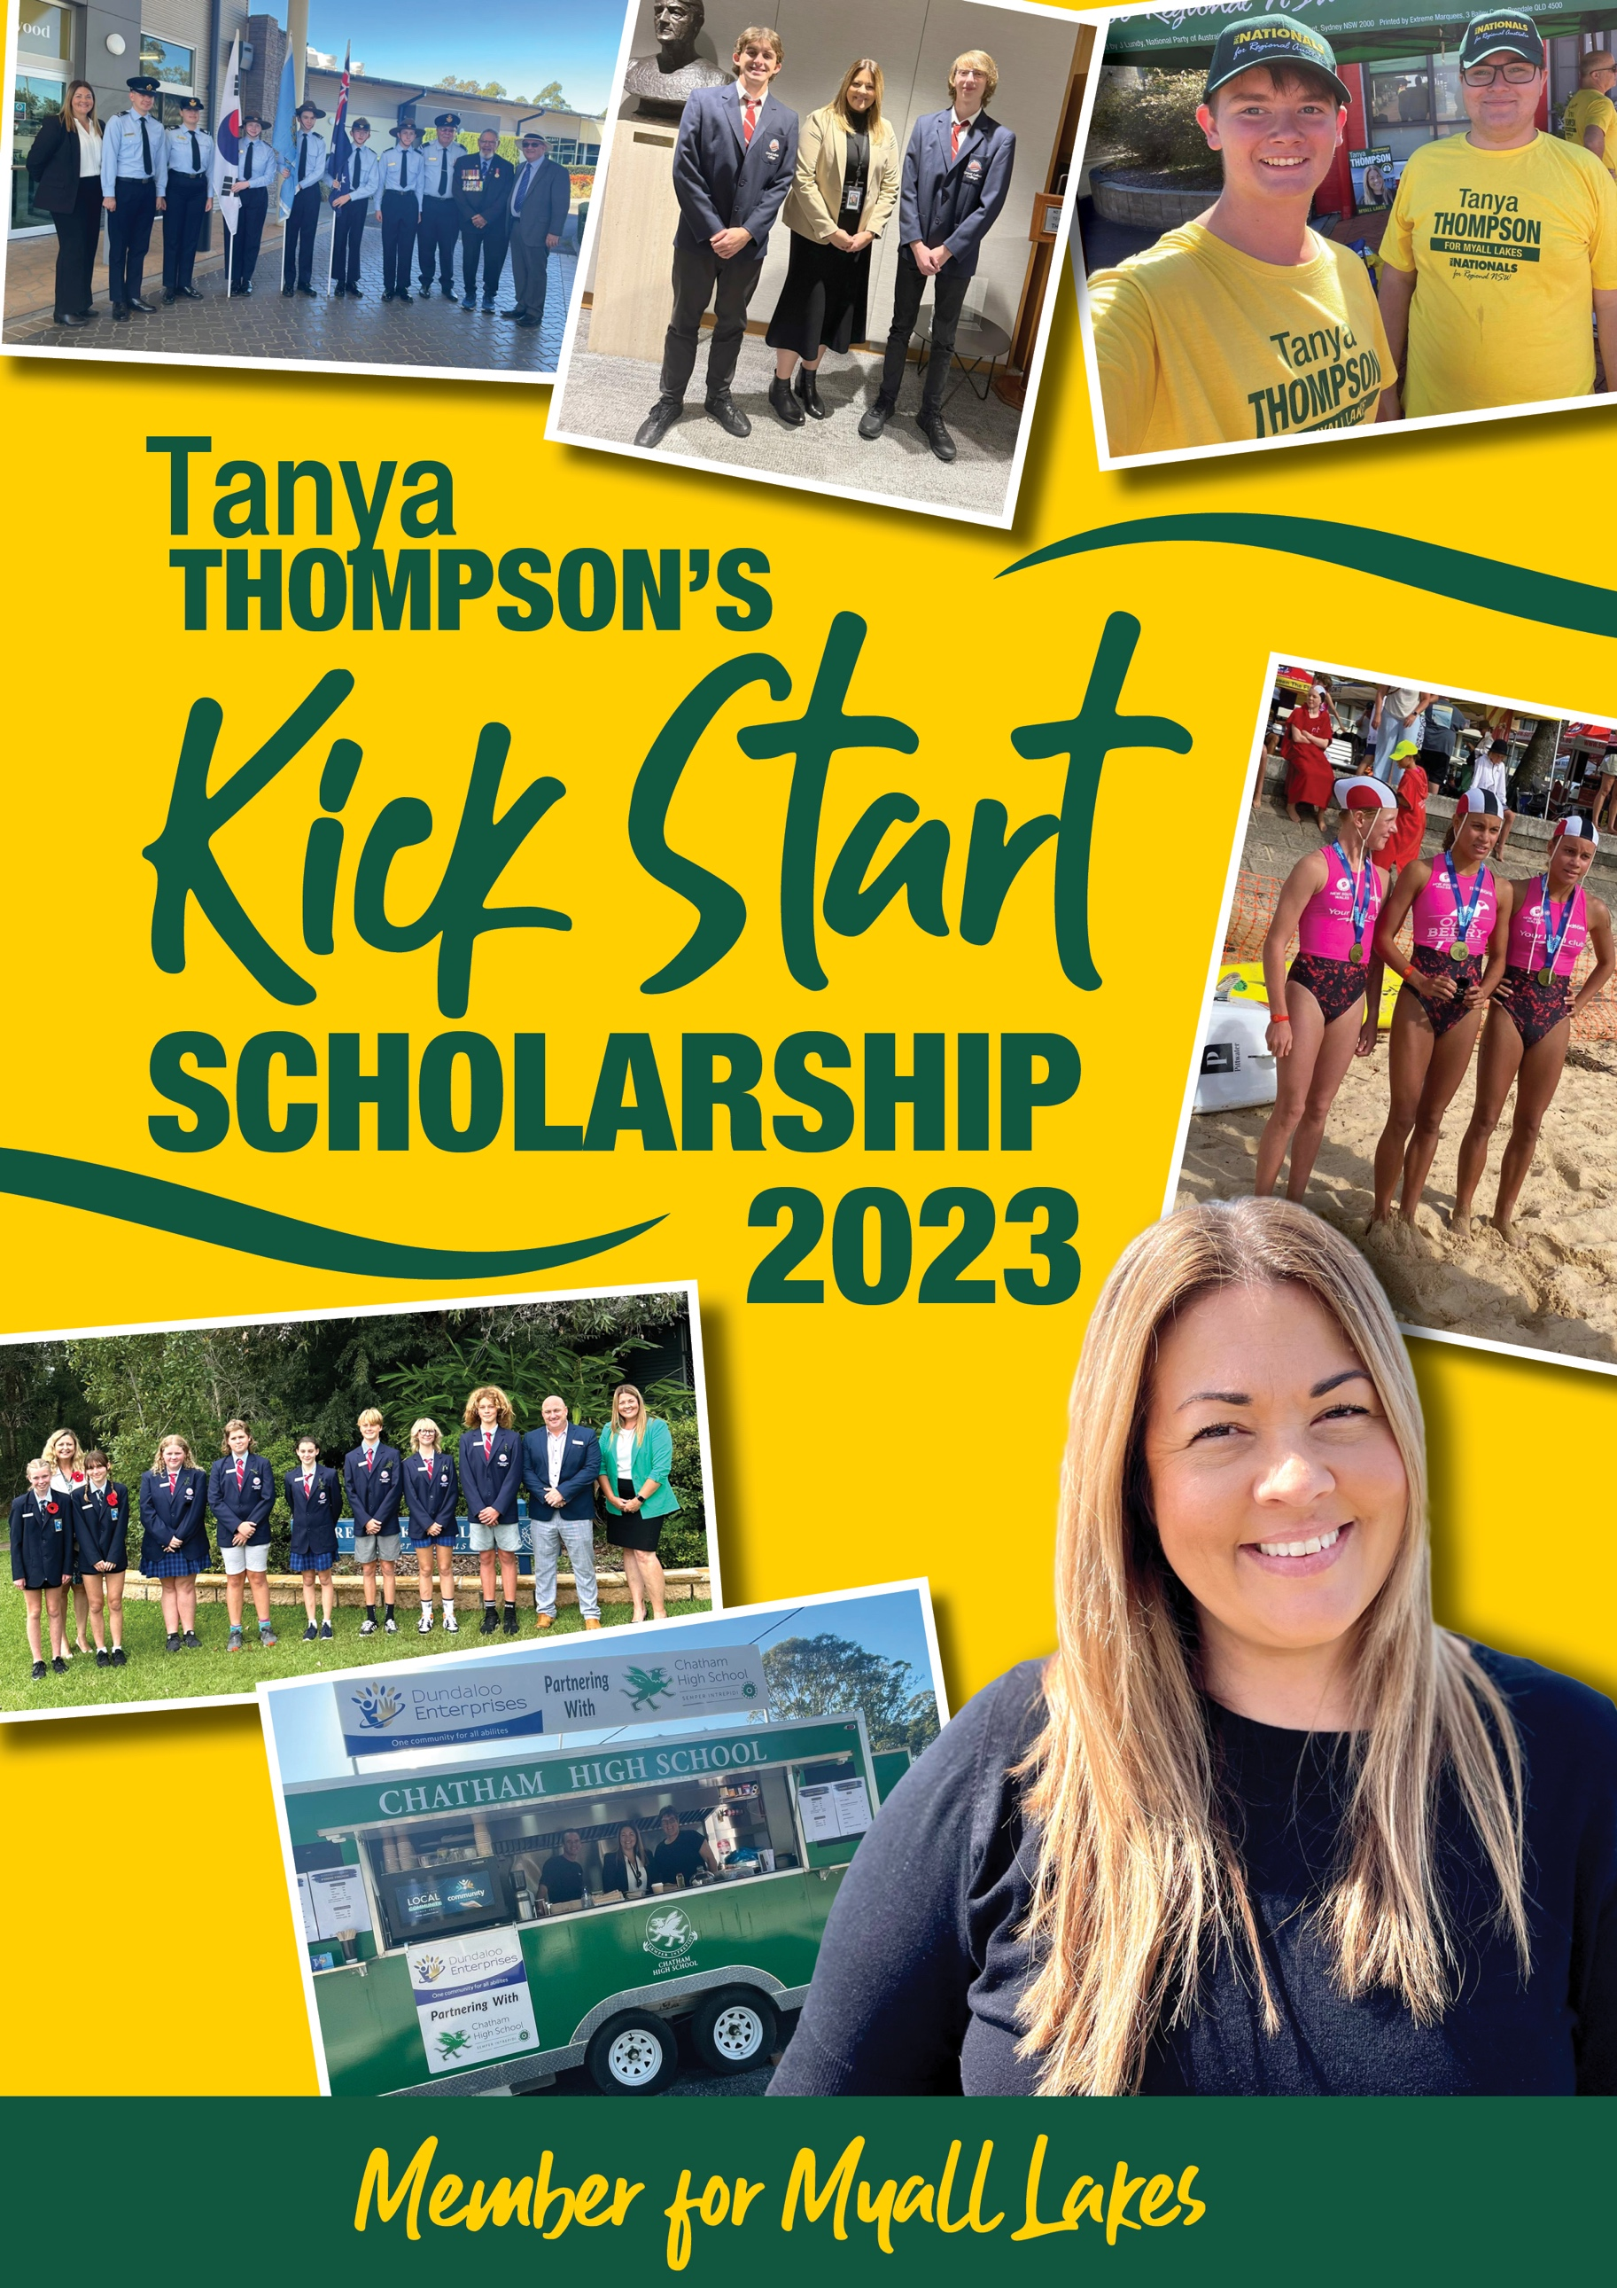

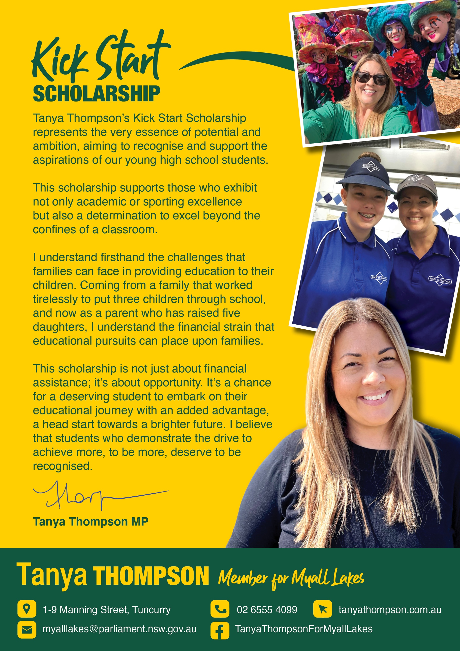

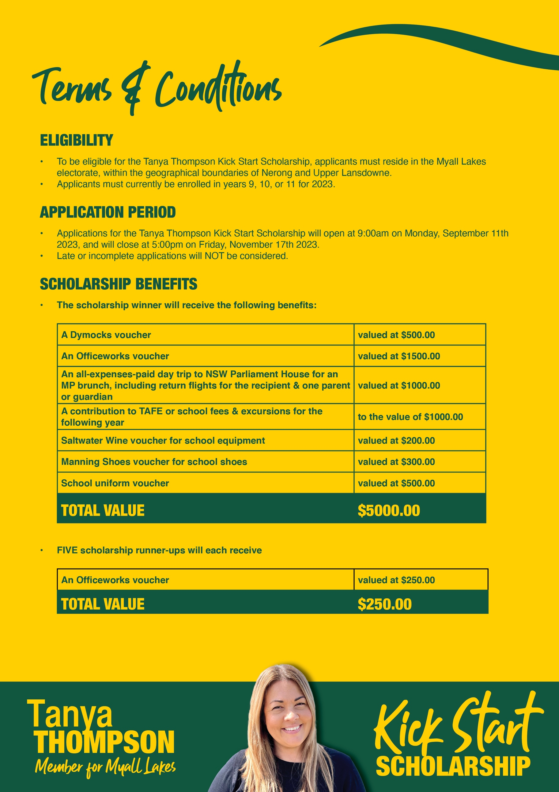

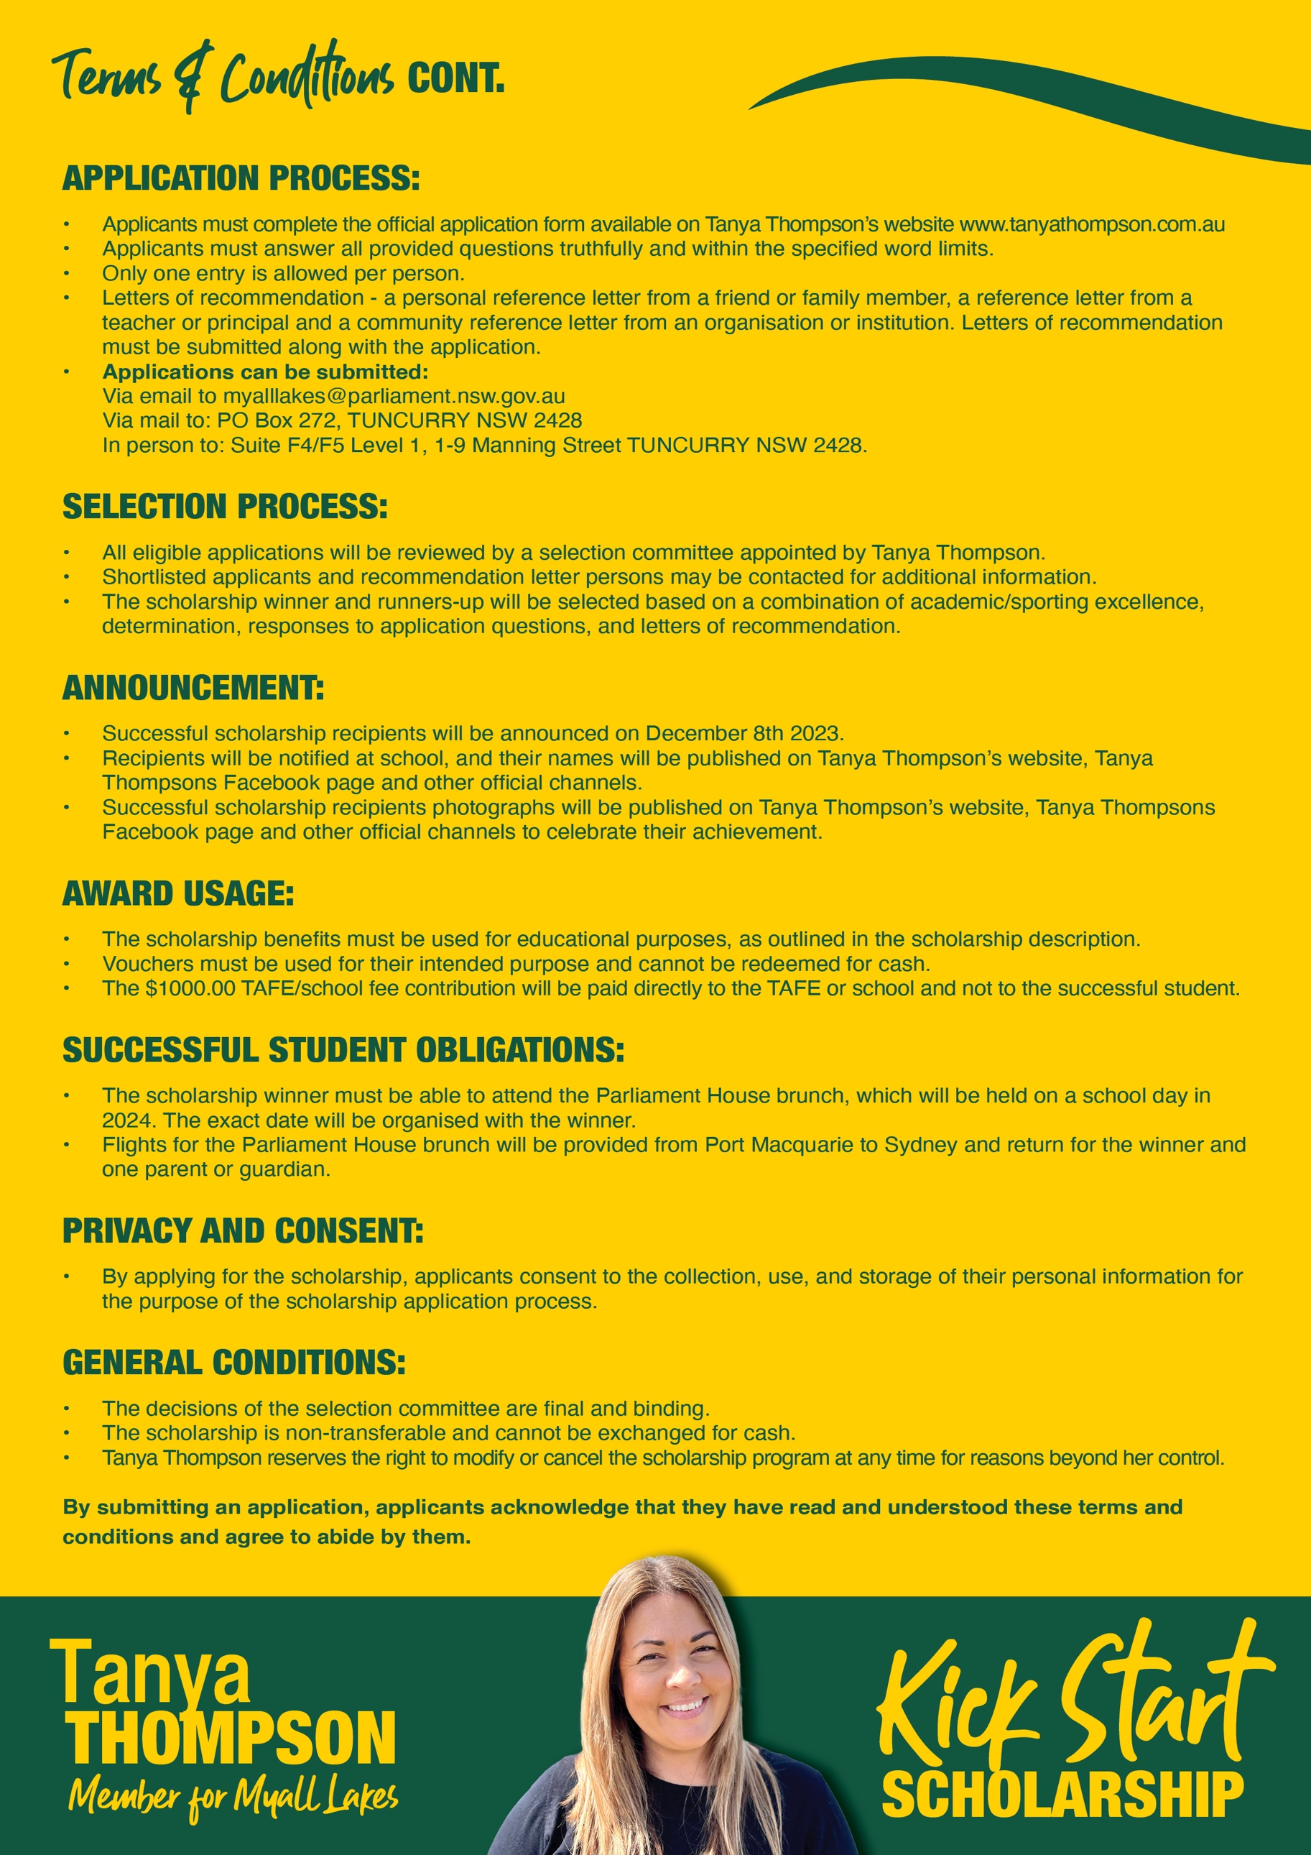

Application Form

PERSONAL INFORMATION:

Full Name:
Date of Birth:
Gender:
Contact Number:
Email:
Address:

Parents Full Name:
Contact Number:
Email:

EDUCATIONAL BACKGROUND:

High School Name:
High School Year:
What extracurricular activities do you participate in?:

QUESTIONS:
- Is your passion academics or sport?

- What are your favourite school subjects and why? (Max. 300 words)

- Who inspires you and why? (Max. 300 words)

- What are your plans after you finish high school? (Max. 300 words)

- Why do you believe you are a suitable candidate for the Kick Start Scholarship?
(Max. 500 words)

- What would winning the Kick Start Scholarship mean to you, how would it help you? (Max.300 words)

LETTERS OF RECOMMENDATION:

To support your application, we require:
  - A personal reference letter, this can be from a friend or family member,
  - A school reference letter, from a teacher or principal AND
  - A community reference letter from an organisation or institution.

- Personal reference letter Recommender’s Name:
Relationship to you:
Contact Number:
Email:

- School reference letter Teacher / principals Name:
Contact Number:
Email:

- Community reference letter Recommender’s Name:
Organisation/Institution:
Contact Number:
Email:

Declaration:

I hereby declare that all the information provided in this application form is true and accurate to the best of my knowledge. I understand that any false information may lead to the rejection of my application. I have read and understand the terms and conditions.

Applicant’s Signature: Date:

Please submit your completed application form, along with two letters of recommendation:
Via email: myalllakes@parliament.nsw.gov.au OR Via mail: PO Box 272 TUNCURRY NSW 2428 OR
In person: Suite F4/F5 Level 1 1-9 Manning Street TUNCURRY NSW 2428

The deadline for submission is 5:00pm on Friday the 17th November 2023.

